**Administrator dashboard**

* This is where all the privileges of the Electronic Publications(E-pubs) take place, wherein the administrator can:
* View or monitor the E-books Data Analytics, as this is the very first view seen as soon as the Administrator successfully logins into the system.
* The administrator can also see a mini table that has a list of all the e-book records that are in the database currently.
* There are five cards that display:

1. E-BOOKS CAPTURED: The total number of all the e-books captured on the Database.
2. E-BOOKS VERIFIED: Total number of e-books verified by all Cataloguers.
3. BOOKS STILL PENDING: Total number of e-books that are still pending; books that are assigned to relevant Cataloguers but have not yet been verified or reviewed.
4. BOOKS UNASSIGNED: Total number of books that are most recent to the E-pubs database and have not yet been assigned to any Cataloguer.
5. BOOKS ASSIGNED: Total number of books that are assigned to all Cataloguers.

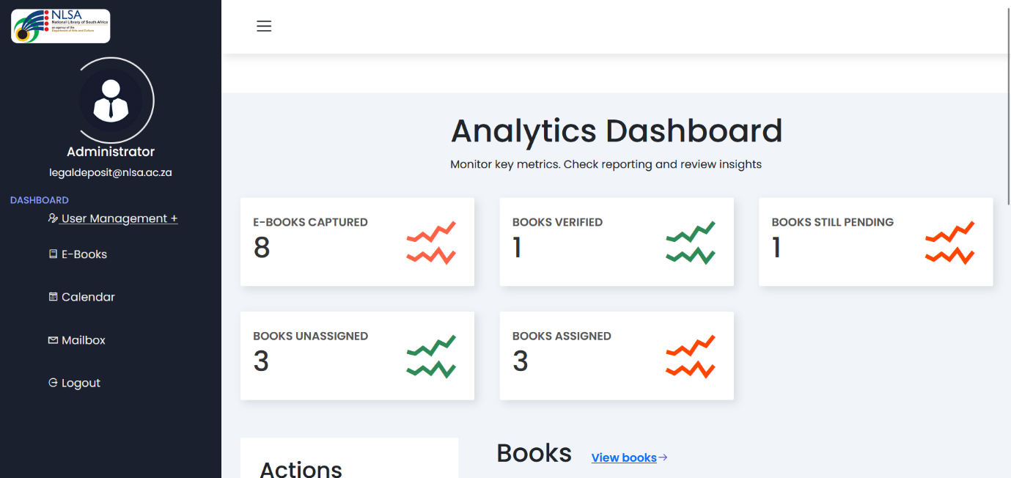

* Perform User management activities:

**Task**: Assign tasks to different Cataloguers within NLSA to review or verify if the e-books received from both Self-publishers and Commercial publishers on the Web application are correct and accurate. There is a table that contains the few book properties for each e-book.

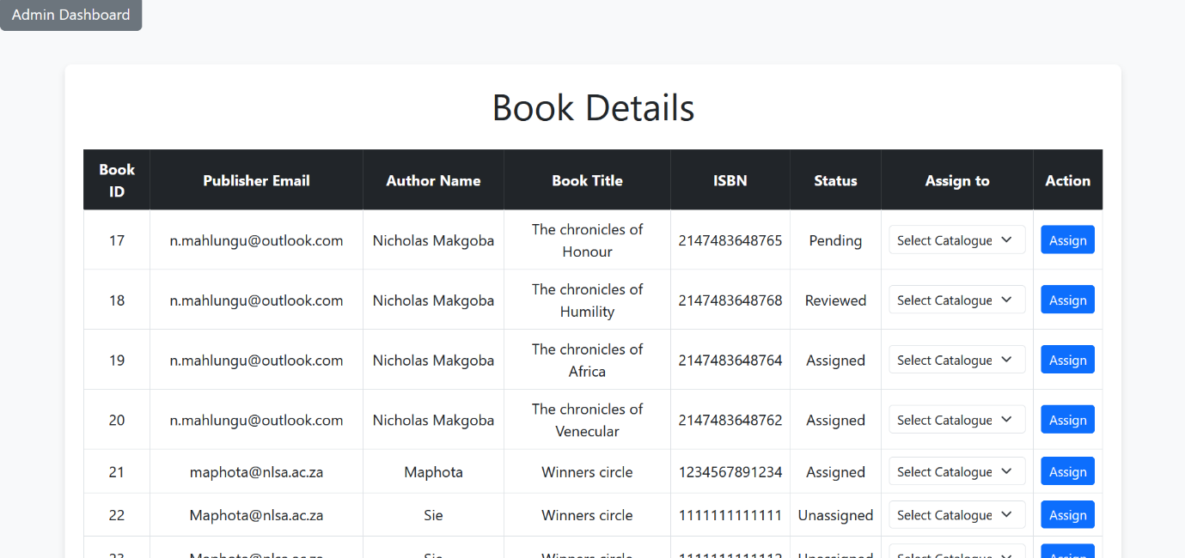

Bottom part:

1. **View Status:**

The administrator is presented with a table of all e-books from the Database, where they can view the status of each book and determine whether it is assigned, pending, unassigned, reviewed, or not. Additionally, the administrator can see the cataloguer assigned or responsible for the relevant e-book(s).

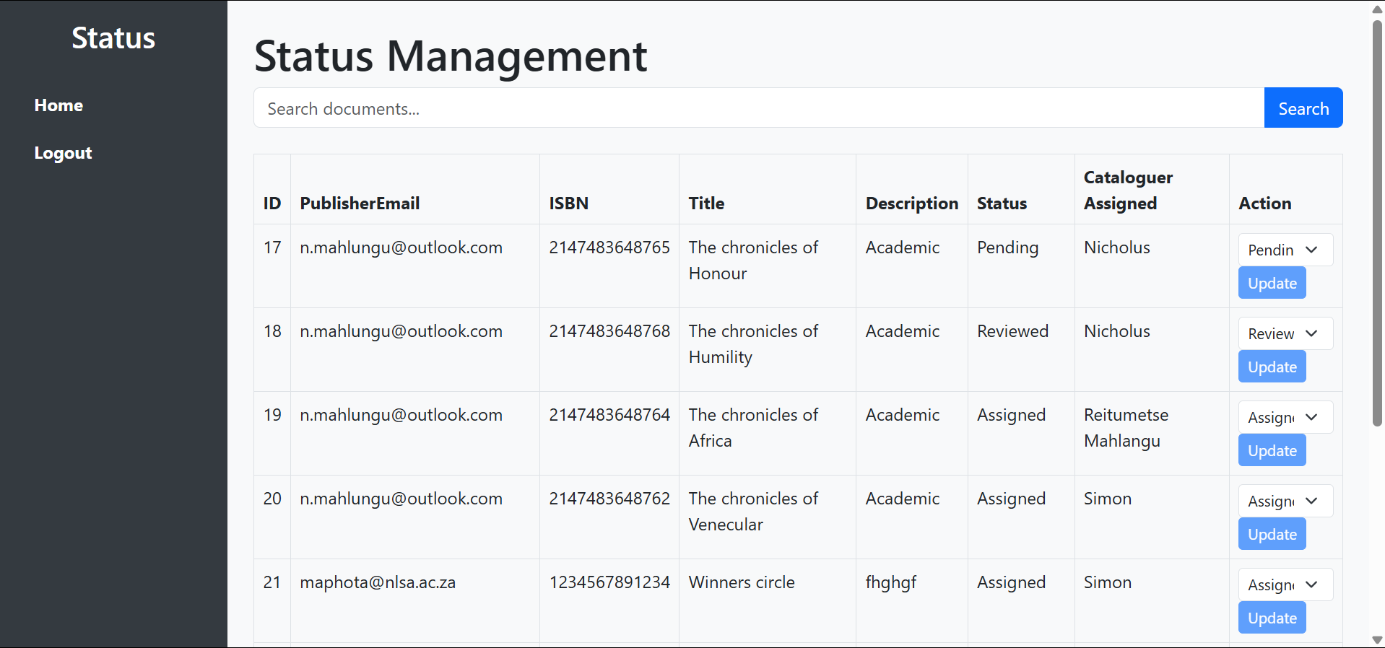

* The administrator is denied access to updating the e-book status on behalf of Cataloguers, as the “update” button is locked and cannot be accessible.
* The administrator has two navigation buttons; one is for re-directing back to the Admin Dashboard, while the other one is for logging out of the administrator Dashboard into the admin login page.
* There is also an advanced search option that allows admin to search the e-book records by Book ID, Publisher’s email address, ISBN, Book title, Description, Status, and Name of the Cataloguer assigned to the relevant. The search functionality also allows the admin to include spaces, but it will be able to retrieve the relevant information.

Search by Book ID:

Search by Publisher’s email address:

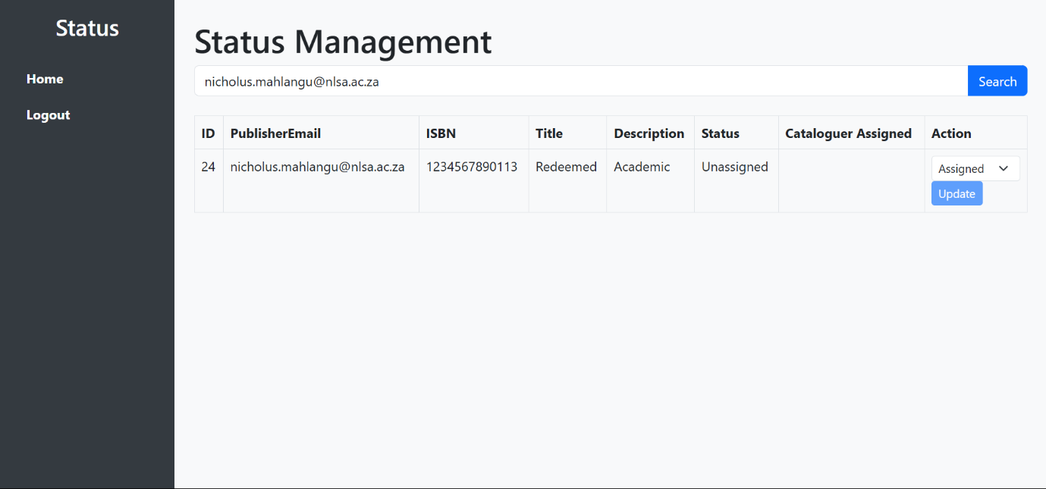

Search by ISBN:

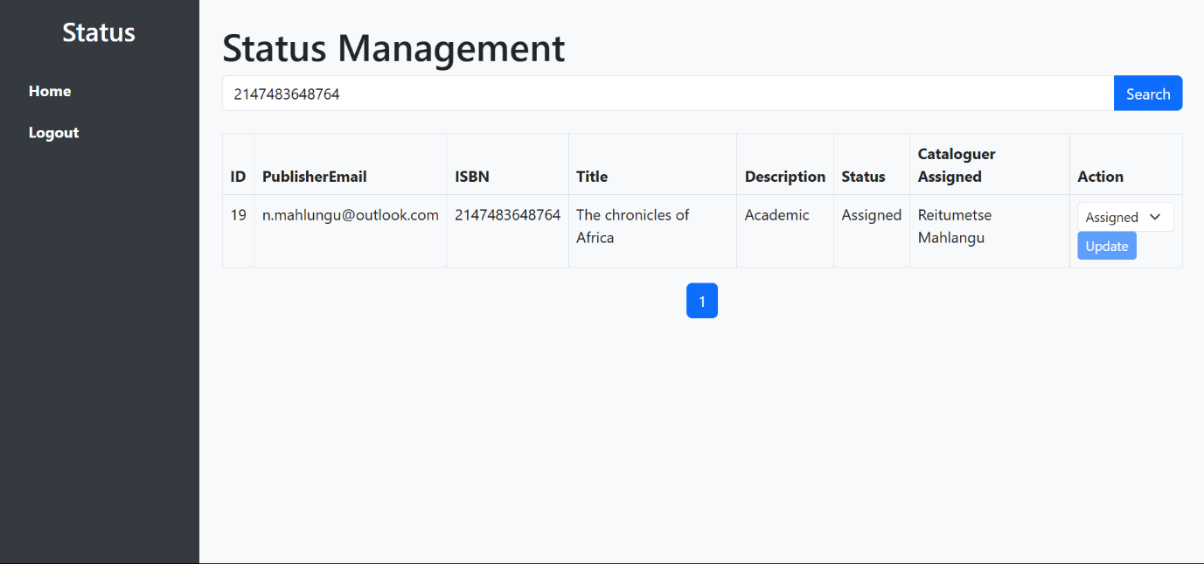

* Search by Book Title: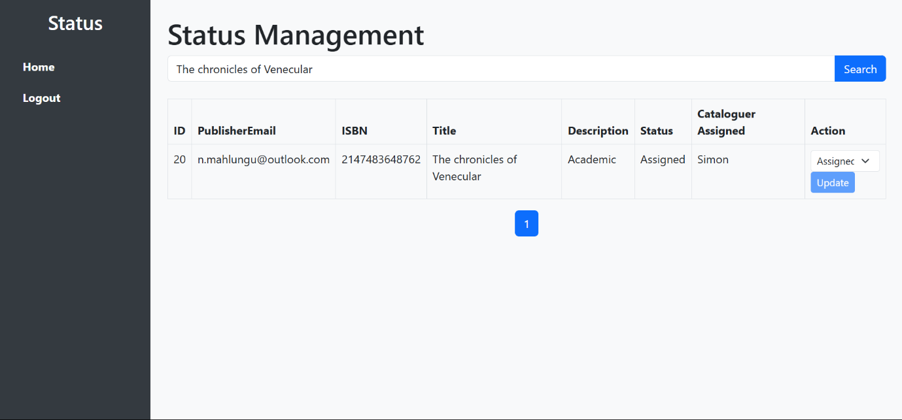
* Search by Description:

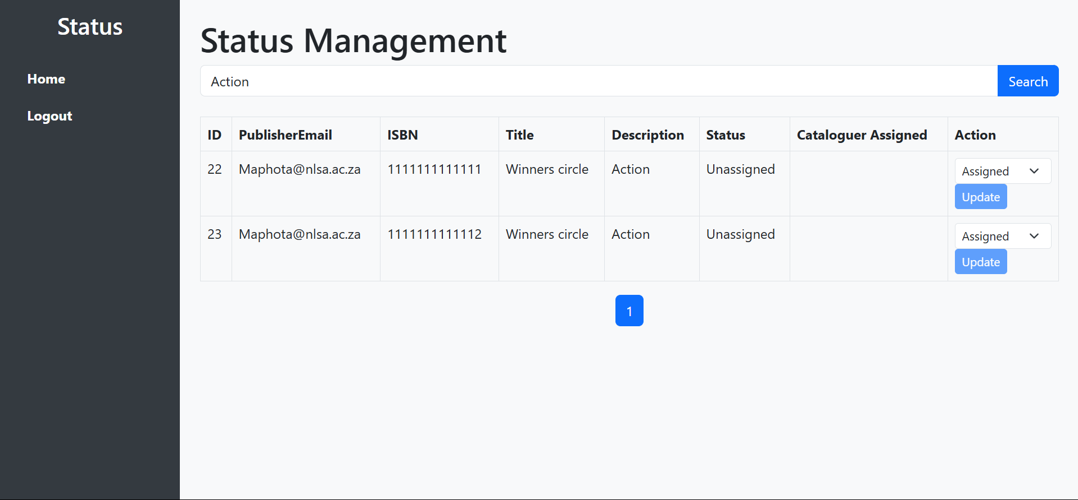

* Search by Description with space:

Search by Status:

* Search by Cataloguer assigned:

* Logout page

* Administrator Calendar

* Add a new Cataloguer into the system from the Admin dashboard.

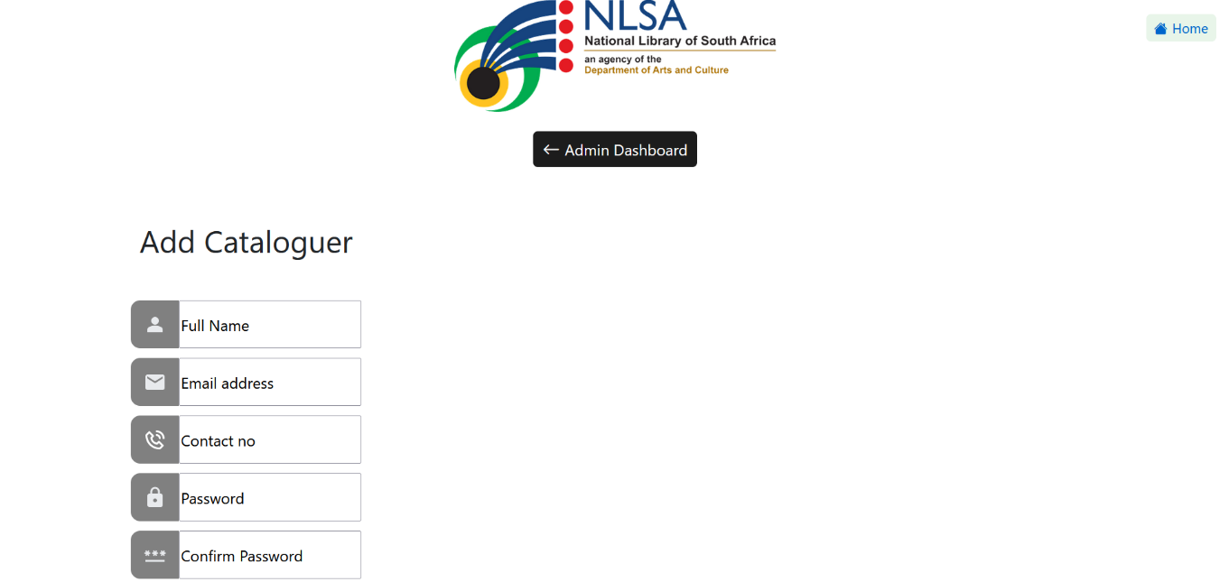

Bottom part

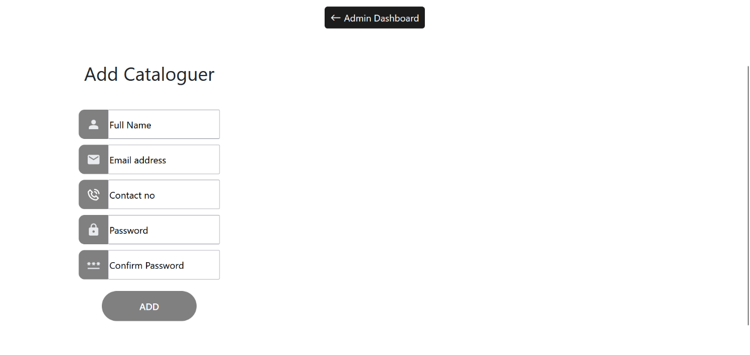

* E-Books: A list of all the E-books captured on since day 1 on the E-pubs web application. The administrator can also click on the “Edit” button under the “action” button to be able to access the book information for each electronic book.

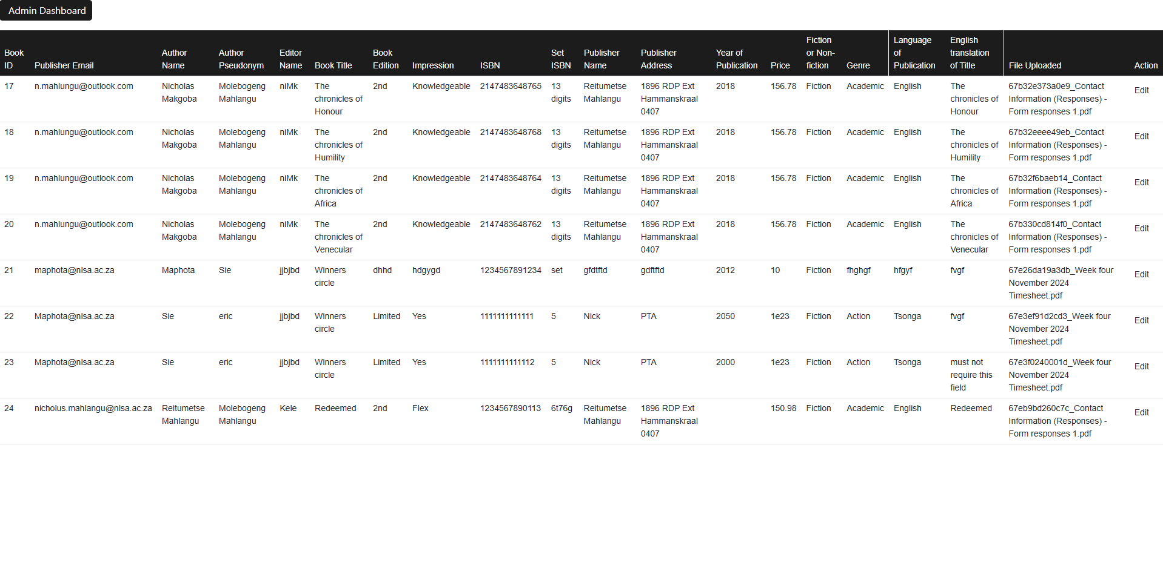

* This is where the Administrator is able to update or edit e-book Information, but only for selected fields. A screenshot of a computer

  AI-generated content may be incorrect.
* This is where the Administrator is able to update or edit e-book Information, but only for selected fields (bottom part).

